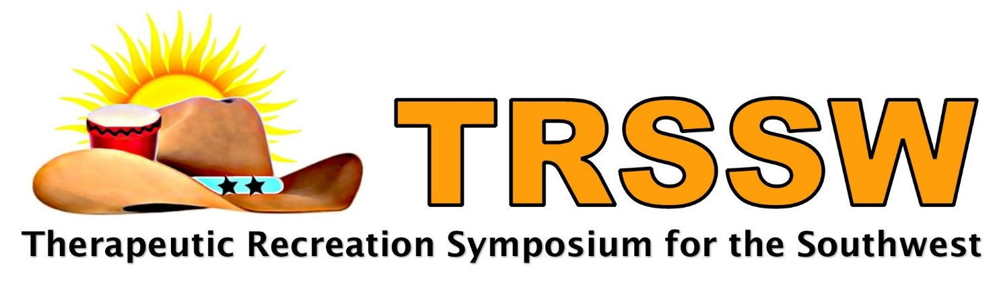
TRSSW 2023: Inspire and Ignite
Session Proposal
Submission Deadline: June 15, 2023
Submit to: cmcmahan@atu.edu
Please save the file as “First Name.Last Name.Session Name” before submitting

Symposium details at: www.trssw.org

November 8 – Pre-symposium (1 – 5:30 PM)
November 9-10, 2023 - Symposium
Scottish Rite for Children
Dallas, Texas

Session TITLE: 10 words or less – descriptive of content; related to the NCTRC Job Analysis located at this link: https://www.nctrc.org/wp-content/uploads/2019/05/JobAnalysisReport.pdf

BRIEF Session Description: 50 words or less - descriptive of content; related to the NCTRC Job Analysis is located at this link: https://www.nctrc.org/wpcontent/uploads/2019/05/JobAnalysisReport.pdf

SPEAKER INFORMATION: The speaker listed will be the primary contact for the presentation. Please provide your full name and complete contact information. Repeat speaker information if necessary.

NAME and Credentials (CTRS,MPH):
Place of Employment Job Title:

Address:

City, State, Zip:

Email: Cell Phone:

Speaker Qualifications: 100 words or less biographical sketch. Describe qualifications to present this topic.

PROGRAM LEARNING OUTCOMES: Provide two (2) measurable outcomes for your session related to the NCTRC Job Analysis located at this link:
https://www.nctrc.org/wp-content/uploads/2019/05/JobAnalysisReport.pdf

Examples of words to INCLUDE:
Define, Repeat, Record, Name, Outline, Recall, Summarize, Describe, Explain, Express, Identify, List, Recognize, Restate, Discuss, Give Examples
Outcome/Objective words to AVOID:
Know, Grasp, Understand, Improve, Appreciate, Learn, Enhance

Example of Acceptable Outcomes:
Identify three benefits of performing evidence-based TR practice
Explain two strategies that have occurred to address TR public policy concerns

Upon completion of this session, participants will be able to:
1)

2)

Program Outline: Provide a detailed outline of content, methodology, and learning outcomes. Outlines must accompany the proposal form. Outlines must have time allotments for each element. Times must total session time checked above.
Outline Example:
- Introduction of the presenter (5 minutes)
- Short quiz (5 minutes)
- Discussion about quiz (5 minutes)
- Self-determination theory (brief overview) (15 minutes)
- Autonomy-supportive environment vs. a controlled environment (20 minutes)
- Autonomy-supportive environment techniques (10 minutes)
- Break into groups to discuss how to relate to their agency/population (20 minutes)
- Wrap up & Evaluation (10 minutes)

To be consistent with NCTRC standards, CEUs will not be approved for a session that is primarily activity based or experiential in nature in which a specific activity or modality is taught unless it is documented that the activity is an intervention. Then, no more than 50% of the session may be activity participation. It is mandatory that an outline of the session be included.

Instructional Methods: (Methods used to achieve learning outcomes) (Please check all that apply)
Lecture | Discussion | Interactive | Panel | Other: please explain

Session Length: (Please select one)

90 minutes | 180 minutes | Other: please explain

Preferred Room Set-up: (Theater is the norm, others may be available). (Please check one)
__Theatre (rows of chairs) __Activity (Open area with chairs along the wall)
__Classroom (tables and chairs) __Other:________________________________

Audio/Visual Equipment:
Speakers should bring presentation on USB flash drive.
Microphones are only provided for Keynote or General Sessions. All rooms have computer and projector with sound speakers.

Describe any additional AV needs:

SPEAKER CREDITS: Handouts and incidental expenses are the responsibility of the speaker(s).
No handouts will be made onsite. Speakers may earn TRSSW registration credit at a rate of $50 per 90-minute session presented. If more than one speaker is involved, the registration fee reduction may be shared between speakers. Please indicate what percentage to award to each speaker.
Name: ____ %
Name: ____ %

PROPOSALS ARE DUE JUNE 15, 2023
Submit to: Dr. Cathi McMahan at cmcmahan@atu.edu
Please save the file as “First Name.Last Name.Session Name” before submitting

For additional information please contact:
Dr. Cathi McMahan
cmcmahan@atu.edu
(479)968-0385

Thanks in advance for your interest in the 2023 TRSSW!

